2021/11/07 1600

Statistical setting:

simu <- function(multi, n, m, sigmax = 5, sigmaep = 1){

X <- runif(n\*multi,0,4\*pi)

Y <- mx(X) + rnorm(n, sd = sigmaep)

return(data.frame(X, Y))

}

Mx(x) = sin(x)

I used n = 32, m = 9 and test dataset size 64. The test data and training data are resampled from dataset of size 128.

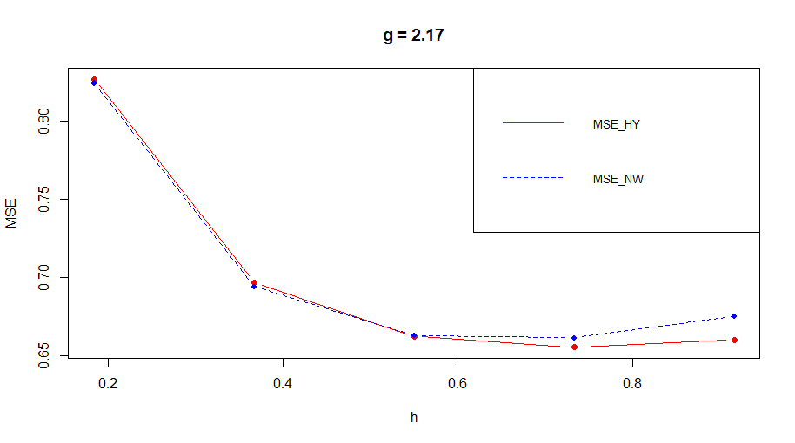

The final result looks pretty good. The optimal h for hybrid estimator is larger than that of NW estimator. And two mse are basically the same when h is small.

The original code is available at Simulation3.Rmd.

The second experiment is based on m(x) = x^2. Similar results were founded.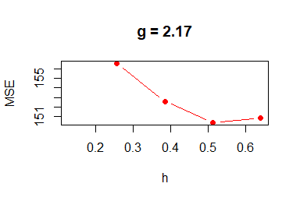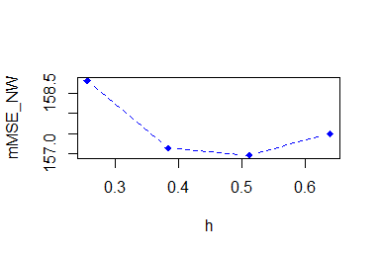

Third experiment: m(x) = x^2, point estimate at x = 2. Using resampling to find the best h and g and estimated average mse.

